**EXPERIMENT : 10**

CONFERENCE MANAGEMENT SYSTEM

USE CASE DIAGRAM

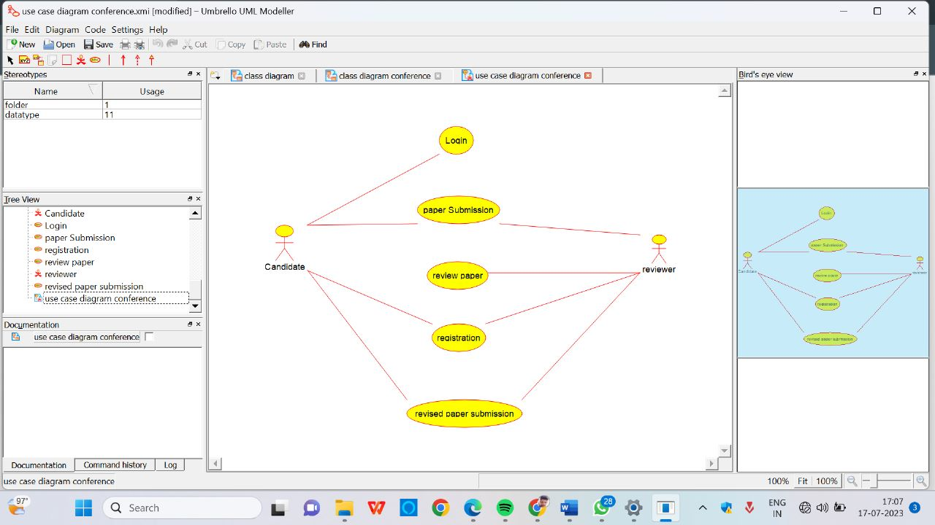

SEQUENCE DIAGRAM

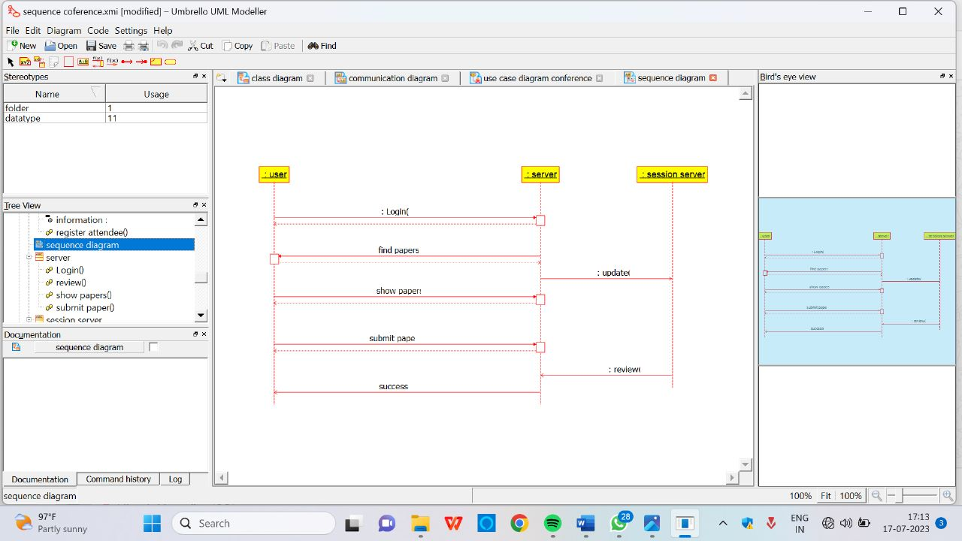

CLASS DIAGRAM

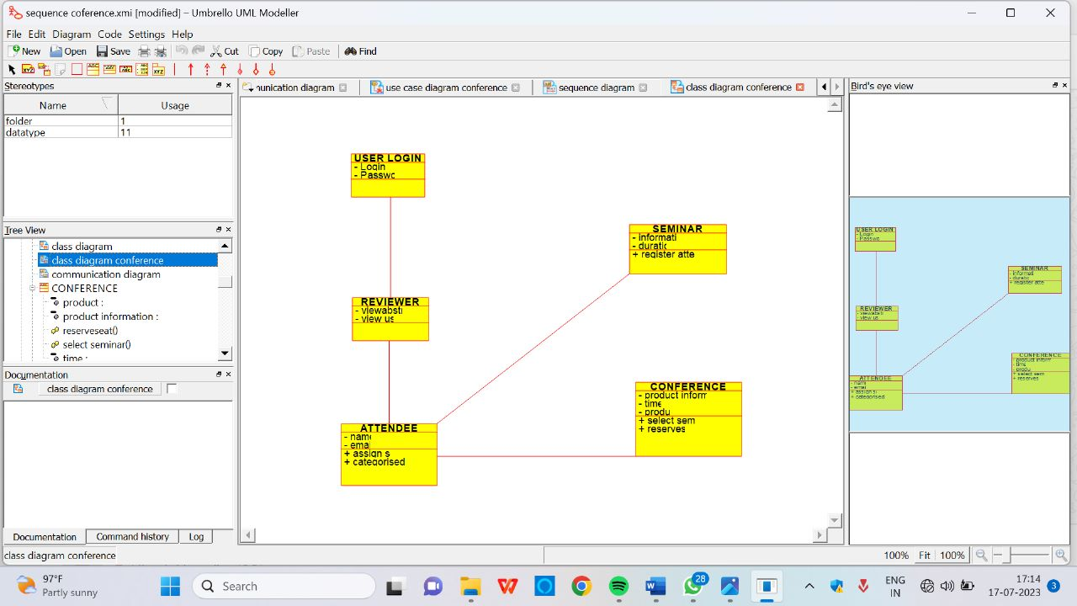

ACTIVITY DIAGRAM

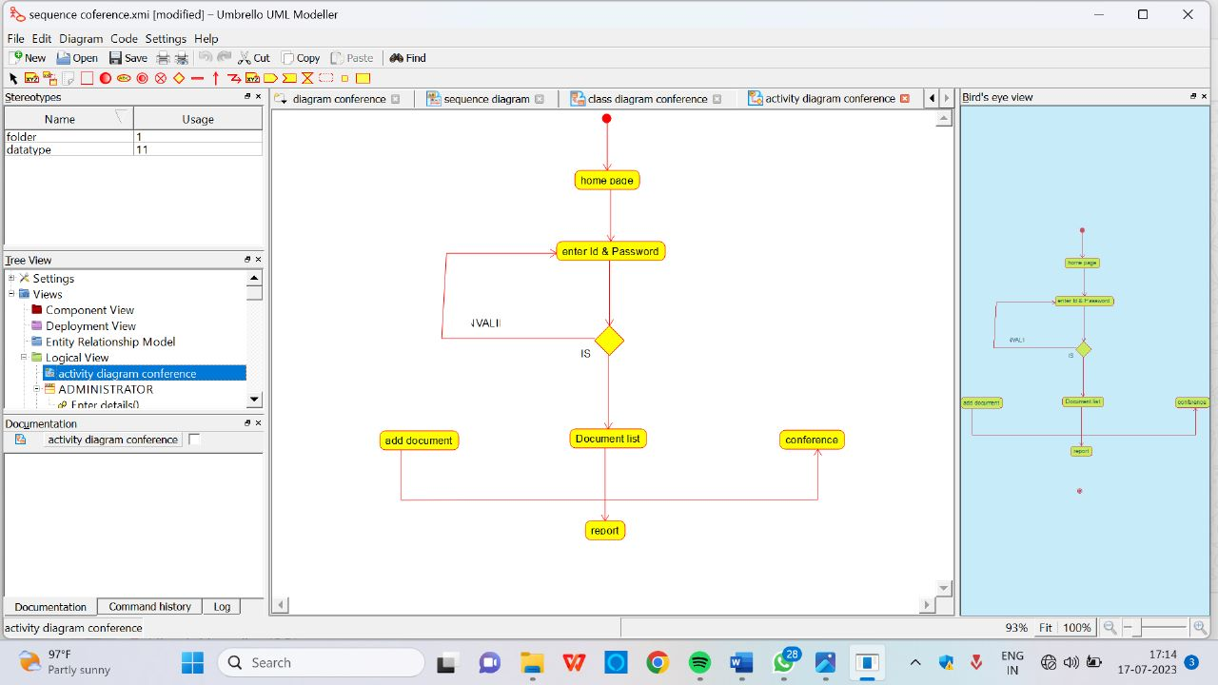

COLLABARATION DIAGRAM

